Functional Specification
Home Security Threat Analysis
Luke Savage(C00248077) - 4th Year Cybercrime & IT Security

Contents
Introduction 2
Requirements 2
System Requirements 2
Functional Requirements 2
Requirements of an Application 2
Home Page 2
Scan Page 3
Result Page 3
User Page 4
Device Page 4
Contact Page 4
Use Case Diagram 5
Application Actor 5
Diagram 5
Application Process of Use 6

Introduction
In this document, I will outline the functional specification for my project. I will cover the requirements that will be needed for this project, System Requirements and Functional Requirements. I will also discuss the requirements for the application and the layout I hope to portray with each page with the use of Images provided. I will also include a use case diagram to provide a better understanding of the applications use.

Requirements

System Requirements
The aim for this is to run it on the two major Operating Systems, these are Windows and Linux. I am unable to test this tool on other platforms such as MacOS. If there are any further requirements that may be encountered in the future, these will be included within a Git Repository.

Functional Requirements
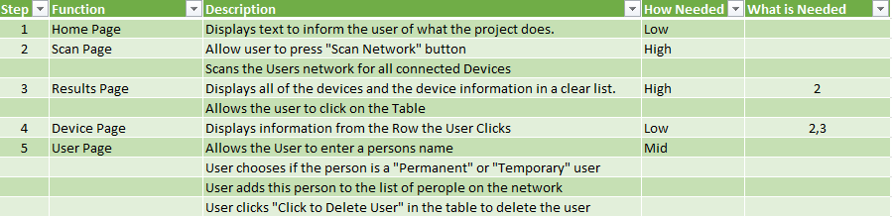

Requirements of an Application
I will briefly explain each page that the application will have. I have included a Home Page, Network Scanning page, Results page, users page and a Contact page. The aim is to scan the users’ network, get a list of their devices and all the necessary information included with them. I will include example screens for each page so there will be a better understanding of how it will work/look.

Home Page
The home page is designed to inform the user of what the application does, and what each of the buttons that are displayed on the left hand side of the screen. It is designed with the aim to be user friendly for anyone that is not tech-savvy.

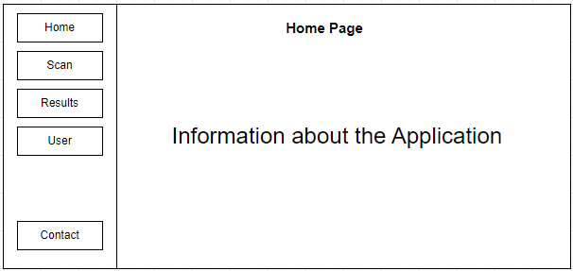

Scan Page
The scan page just displays a button with the text “Scan Network” on it, when a user clicks on the button it will take the devices IP address and then replace any number after the last “.” with .0/24 and then perform an intense Nmap scan of their network. For Example, if the device IP is 192.168.1.1 the Nmap scan will be scanned against 192.168.1.0/24. It will then output the Nmap results into a file called nmap_output.txt in a folder called Project in the user’s home directory.

Result Page
After the scan is performed, the result page will appear on the user’s screen. Depending on whether they did the Network Scan before visiting this page they will be greeted with a table that displays in a clear list the devices, IP Addresses, Mac Addresses, OS, and Manufacturer, depending on the results of the scan. It reads the results from the file created from the previous Scan page. If the user visits this page before the Scan is done, it will print the text “Please do a Network Scan.” Instead of an empty table.
Before Scan:

After Scan:
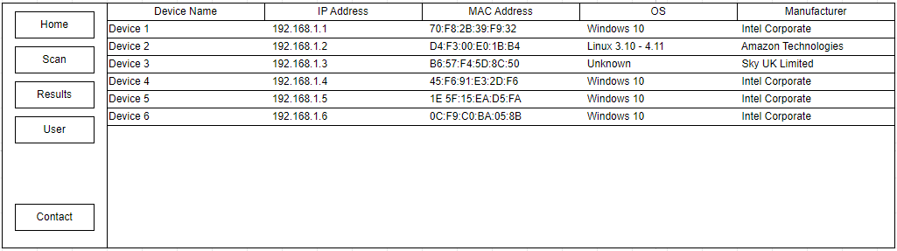

User Page
The User page is a manual system that can be used by the user to keep track of the people they allow onto their network. The user just types in the name of the person, then selects “Permanent” or “Temporary” depending on their status in the household. A permanent user would be someone that lives in the house, while temporary would be a visitor or someone staying for a few days. It is also very easy to remove users from this list, all that is needed is to click the third cell of every row in the table. The application keeps track of the names on the list by storing them in a file called “myusers.txt” which is stored in the same folder called Project as the scan results.

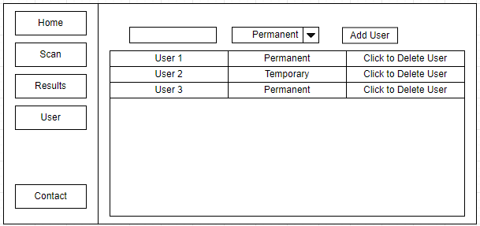

Device Page
After clicking on a specific device in the Results page, this page opens and shows all of the valid information for that row in the table, or device, such as its Device Name, Model, OS, IP, Version, and its MAC Address.

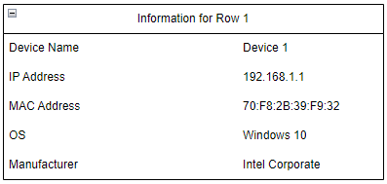

Contact Page
The contact Page just displays Text with information about me. It shows my Name, Student Number, both my college email and my personal email. It also has my college, course, year, and my phone number.

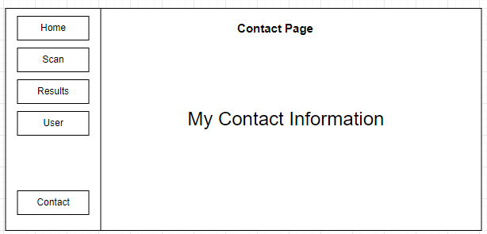

Use Case Diagram

Application Actor
This application will be used by a single user, The admin user of the device. Once the user downloads and opens the application, it will first display the home page, displaying text on what the application is and how to use it. The user can then navigate to any of the pages available, these are: Home, Scan, Results, User, or Contacts.
The Scan page opens to a button in the middle of the page, once the user clicks this it will start an Nmap network scan on the users’ network. Once the scan has finished it will automatically open the Results page displaying the results from the scan in a clear table. If the user clicks on one of the rows in the table, it will open a separate page displaying the information from only that row. The user can then open the User page that has a text box and a drop down menu that gives the options of “Permanent” or “Temporary” and then a button that adds the user to the list using the Test and the drop down box to fill in the information.

Diagram
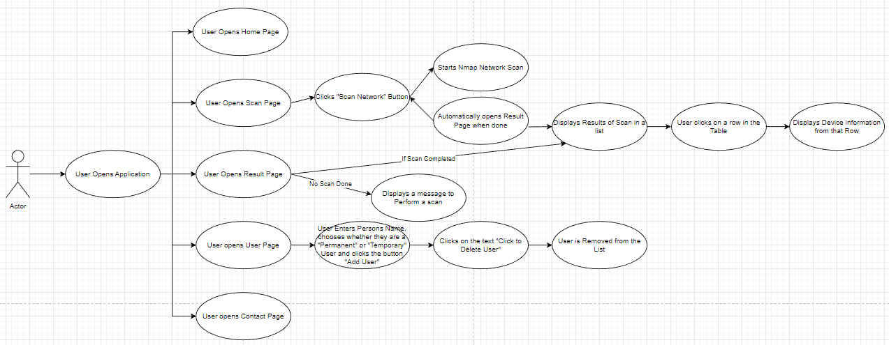

Application Process of Use
